**Funz**

**‘A New Era of Infotainment’**

*Project*

*Submitted in partial fulfillment for the degree of*

**Bachelor of Computer Application**



**Name of Guide:**

Puneet Mathur Sir

**Name of Student:**

Manav Gupta

Shubhranshu Pareek

**Year \ Semester:** 2020-23 \ Ist Semester

**Enrollment No.:**

**Manav-** 2020PUSCEBCAX08605

**Shubhranshu-** 2020PUSCEBCAX08609

**Name of Coordinator:**

Kavita Lal Roy Ma’am

**Department of BCA**

**School of Computer Science and Engineering**



**Poornima University, Jaipur**

**School of Computer Science and Engineering**

**Department of Computer Engineering**

**NSP Project**

**BCA, I Year, I Semester**

**Table of Contents**

1. **Topic of the Project……………………………………………………………………………………… 3**
2. **Objective of the Project …………………………………………………….………………………… 3**
3. **Scope of the Project………………………………………….…………………………………………. 3**
4. **Design…………………………………………………………………………………………………………. 4**
5. **Software Required………………………………………………………………………………………. 6**
6. **Contribution by each Member…………………………………………………………………….. 7**
7. **Process/Methodology…………………………………………………………………………………. 7**
8. **Limitations Faced………………………………………………………………………………………… 9**
9. **Resources……………………………………………………………………………………………………. 9**
10. **Testing………………………………………………………………………………………………………… 9**
11. **Future Work/Updates…………………………………………………………………………………. 11**
12. **Conclusion…………………………………………………………………………………………………… 12**

**Topic of the Project –**

Since our Team decided to create an Application in the format of C language, we decided to make an Application which gives users an Entertainment Source but still with a plenty of knowledge.

That’s the reason why we call our application Funz “A New Era of Infotainment”.

It is basically an Entertainment Application which passes Knowledge to its user. The Application consists many different Activities in it for e.g., MCQs, True or False, and so on. The application is entirely bug free. We Created the Application in such a manner the user only has to click few keys to operate Funz.

Our approach to the Application was to make it easy to function for every possible user. The most amazing thing about this Application is that it only takes less than 1% of your CPU usage and less than 20 MB of RAM.

Moreover, we proudly present our sponsor Celestial Gaming.

**Objective of the Project –**

Our main objective for creating this application is to give the users a source of Knowledge with a competitive spirit with less time consuming and system consuming methods. There are many Applications out their in the market, but only few are good enough in terms of entertainment, knowledge, accuracy, accountability, and user-friendly environment. So, we tried our best to cover those points with some Competitive Spirit in Users to compete with others. Also, we have made separate games, so it is completely your choice that what game do you want to play.

**Scope of the Project –**

Applications with Infotainment has a Vast Scope in Future. It can be updated time to time and can be released with a lot of multiple features, and there is no such word limit in these applications.

Our Application is Free of Cost, Users are not bashed with Advertisements, only thing we use is sponsorship which is just a line of Statement.

In last, an application with User-Friendly Experience has a vast scope.

**Design –**

It was the most important and one of the most discussed part of the entire project because First Impression is the last one. So, we first decided that we will we make some designs with patterns but there was a complication because our Application Consist a lot of text so adding patterns will make the case worse and worse. That’s the reason why we relied on print function. We created our own customized Designs with *, -, ~ and so.

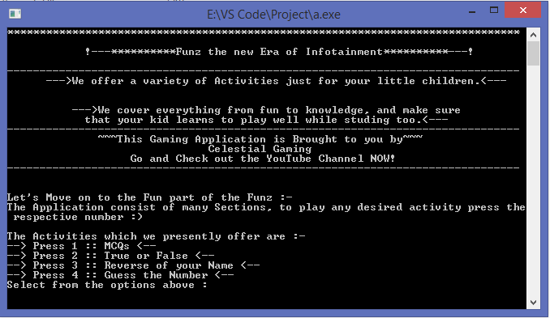

In the Picture above you can see the main menu of our application. It basically provides the instruction to the users with some cool looking designs.

For different games there are different set of designs used with some comments.

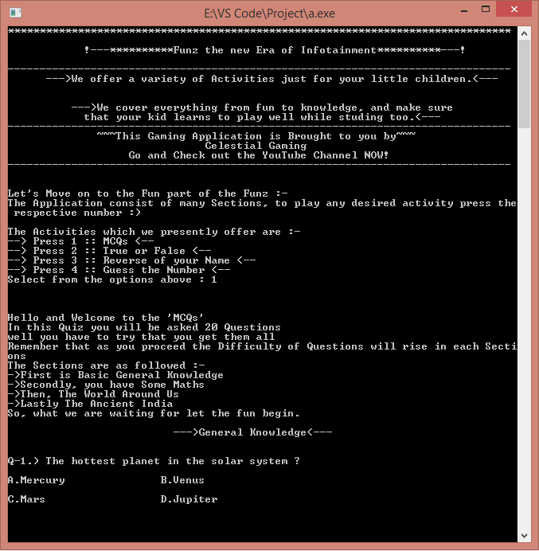

**MCQs:**

We used tab in the questions part to make it look cooler.

**True or False:**

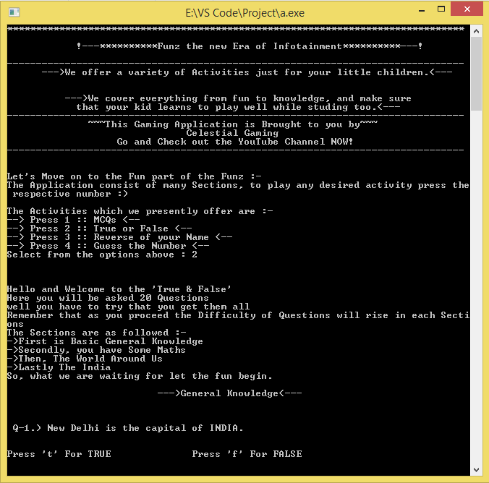

Quite Similar to MCQs but yeah there are only just 2 options true or false.

**Reverse of your Name:**

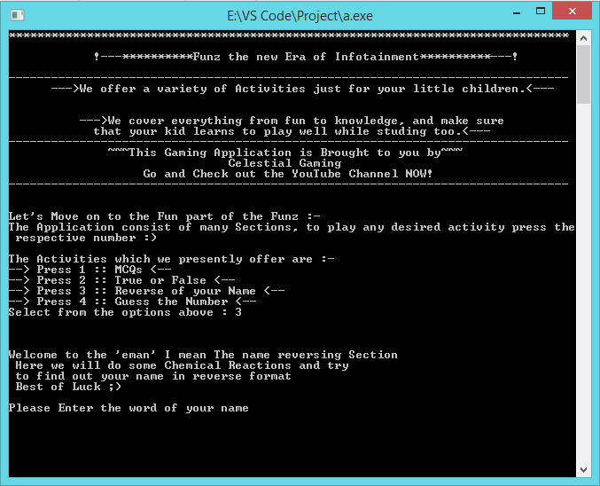

Sometime simple text looks good too.

**Guess the Number:**

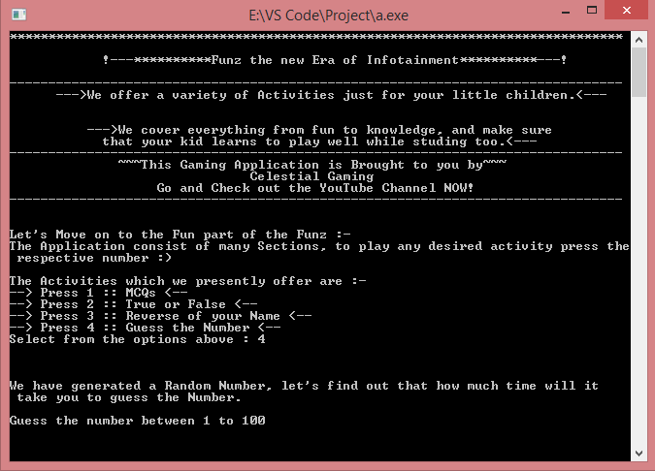

Same as Reverse of your name but it is definitely more interesting.

**Software Required –**

There are only three softwares you actually need to built an application like this; applications required are –

1. VSCode or any other Development Kit like DevC, Code Block, or Turbo C.
2. Compiler like Mingw which Compile C language, but there is no need in the UNIX built Systems.
3. Command Prompt which is actually inbuilt in every system itself or maybe in other form/name.

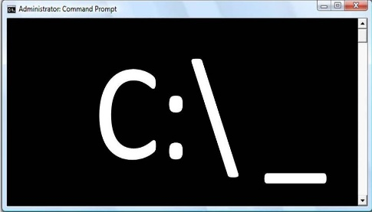

**Contribution by each Member –**

There are only two members in this Project Manav Gupta and Shubhranshu Pareek. Almost each and every code of the Program is written by the Prior Knowledge of the Members which is what so ever is taught by the Teacher. The codes were created in as perfect and understandable manner as possible, each of us used \n and spaces in a manner that the output is very much understandable as the code.

Specific Work by Manav Gupta are:

1. Creating Main Menu which consists printing text and symbols for decoration purpose.
2. MCQs was created by Manav Gupta, doubts like use of toupper were solved with the reference of Book “Programming in C by Reema Thareja”.
3. Guess the Number was created by Manav Gupta, reference was taken from Code with Harry.

Specific Work by Shubhranshu Pareek are:

1. True or False was created by Shubhranshu Pareek, with the reference of the Book “Programming in C by Reema Thareja”.
2. Reverse of your name was created by Shubhranshu Pareek, but there was some error in the code so the team decided not to do changes in the code instead of that they added a Sarcastic text in the end of program.
3. Rules and Instructions of the activities were given by Shubhranshu while discussing with Manav.

If anyone had any doubt then both of them discussed a way out of it. There is participation of both of the members in the Report Making.

**Process/Methodology –**

After taking Funz as the Topic, the team organized a planning session for two days. On day one Both of the Members familied themselves with their topic and prepared an pros and cons table. On day two team discussed about how the interference will be and what activities will be there in the Program. Afterwards every Member created their own Codes by their own, the work was divided as per one’s skills, knowledge and will. As mentioned in Contribution by Members each played their roles.

After the different code files were prepared by each, Manav Gupta linked all of the files in one file titled Funz.c and created a fully functional and responsive Program.

Here are some of the Snapshot of the Funz.c :-

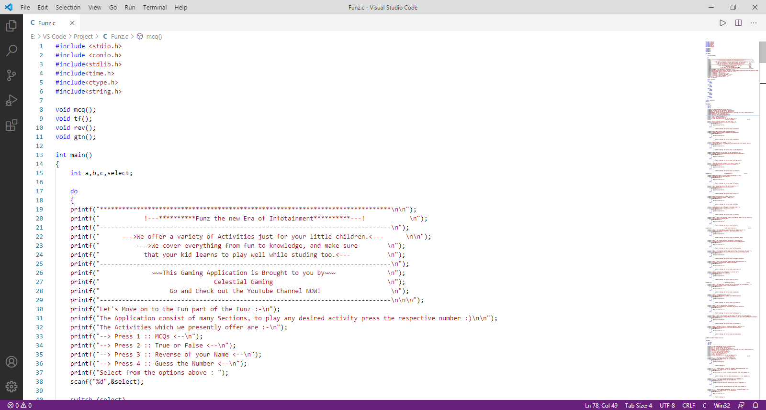

In the above Picture, we declared different functions.

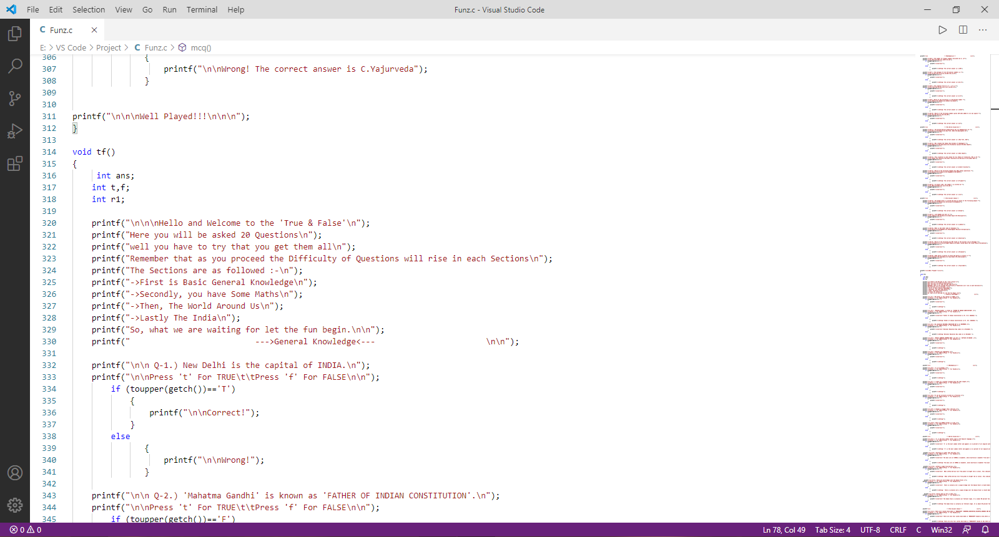

In the Picture above, Every Void is given it’s task like void tf() is for true or false.

**Limitations Faced –**

There were no such huge limitations faced by our team because in the starting only we decided that we will be doing the work with the Smart Way rather than the Hard Way.

Other than this the knowledge given by our teacher was good enough to complete our project without any complications.

**Resources –**

Resources used for this project were :-

1. Notes given by our teacher in Classes.
2. Referencing from the book “Programming in C by Reema Thareja”.
3. Code with Harry (YouTube Channel).
4. Google for searching the use of some functions and declarations like Time.

That’s the only Resources used in the Project by our Team.

**Testing –**

It was the most fun part of the Project because the end result was quite surprising, as every code worked in the first try after linking all the small files in the single one that is Funz.c .

Here are the Snapshots of the Activities in the Output form.

1. Main Menu

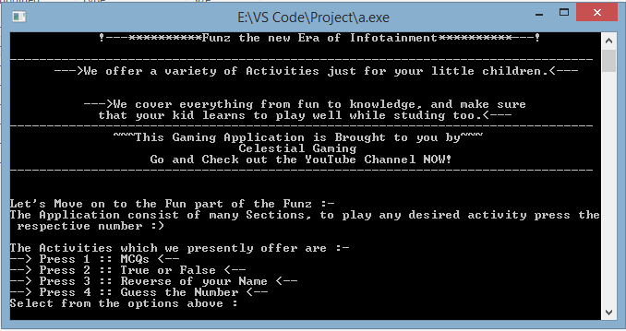

1. MCQs

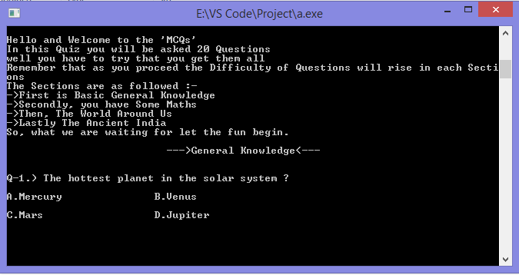

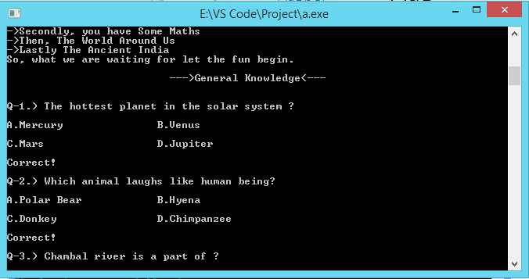

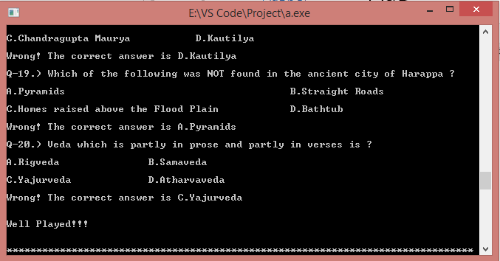

1. True or False

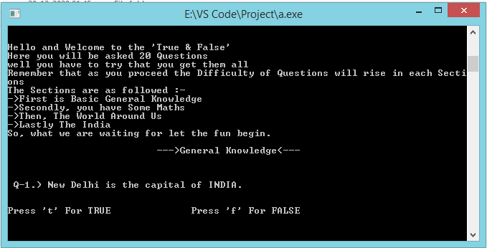

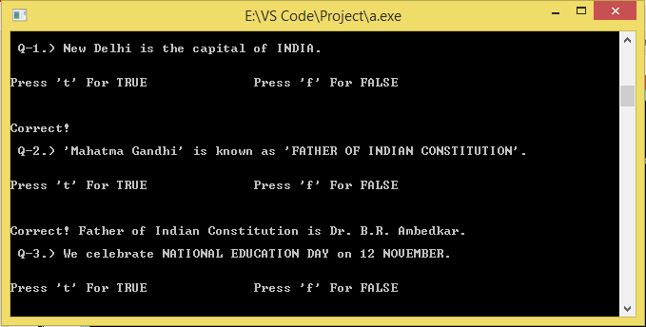

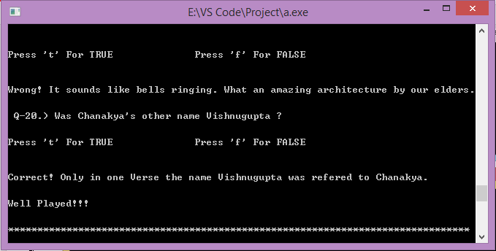

1. Reverse of your Name

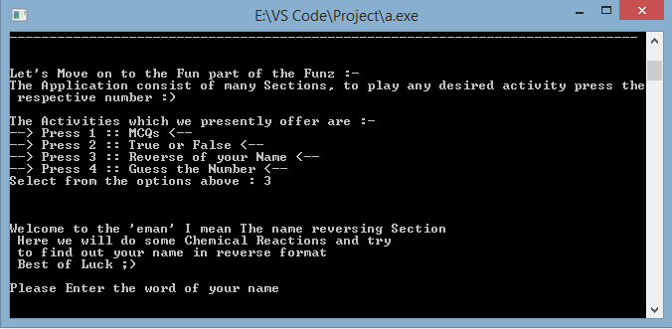

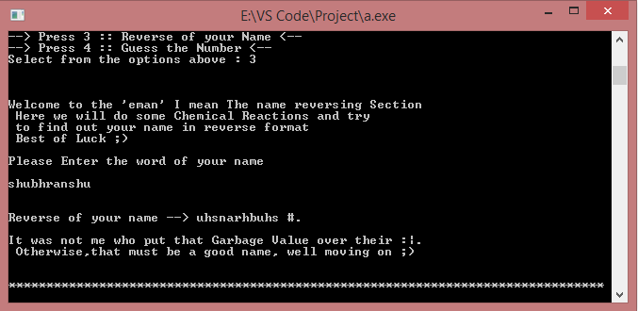

1. Guess the number

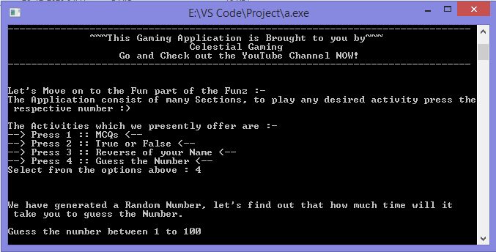

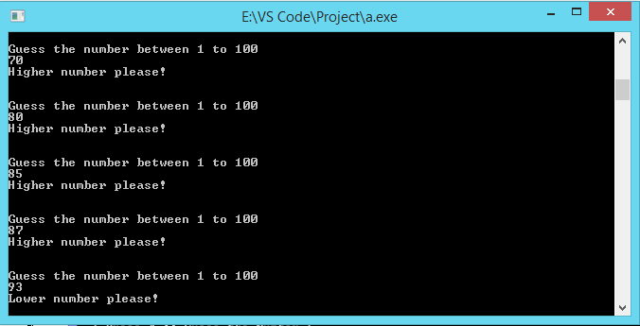

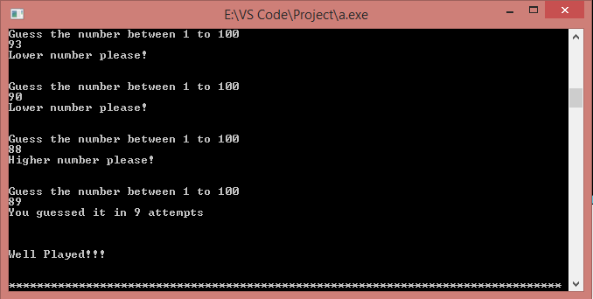

**Future Work/Updates –**

Yes, there is a lot of Future Work to do in this application like,

1. We can add a registration part in this program say “Enter your Name” and like this.
2. We can Introduce Counting System in the Games like “You Scored 18/20”.
3. Last but not the least Introducing more activities in the program**.**

**Conclusion –**

While making the project on Funz “A New Era of Infotainment”. Our Team made a wonderful progress by solving a number of problems in C Language and also found that there are more than one solution for a Problem. Solution to each problem by our team was the most important part of the project and this provided team with experiences which will help us in future.

We get to know use of many functions and declarations in practical form for example use of toupper is Considered for both Capital as well as Small letters.

Some of the important things that we learned include designing a good program and converting real life realizations in mind into an efficient code, and how to write a good looking easily readable and understandable as well as time and memory efficient code.

After the completion of the final part of the Project, Team discussed a lot that can be changed in future activities if the project will be carry forward.

In last the Project helped us a lot by explaining us how real-life problems can be solved by a Line of Code.